8.1 - Sketch the state diagram and draw the derived circuit.

Question:

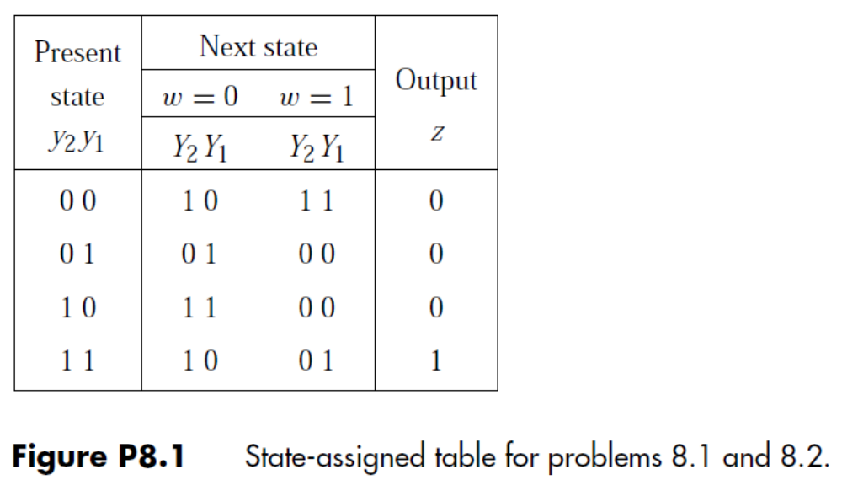

Solution:

8.2 - Hint: determine the JK settings needed to achieve 0->0, 0->1, 1->0 and 1->1 transitions in the flip-flops.

Question:

Solution:

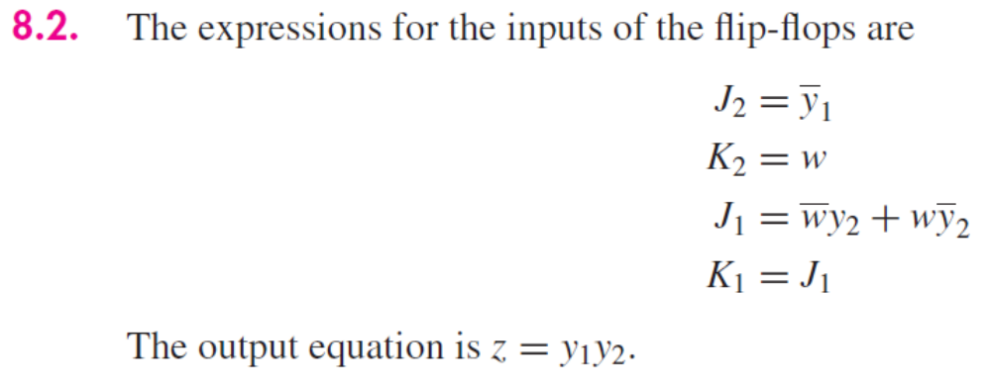

8.3
a. Assume you are designing a Mealy machine
b. Derive the state table for problem 8.3 and derive the circuit using T-type flip-flops.

Question:

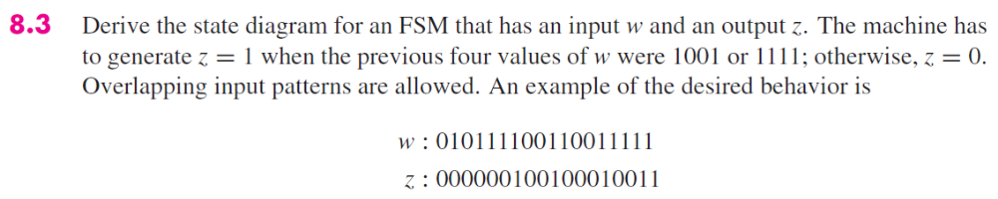

Solution:

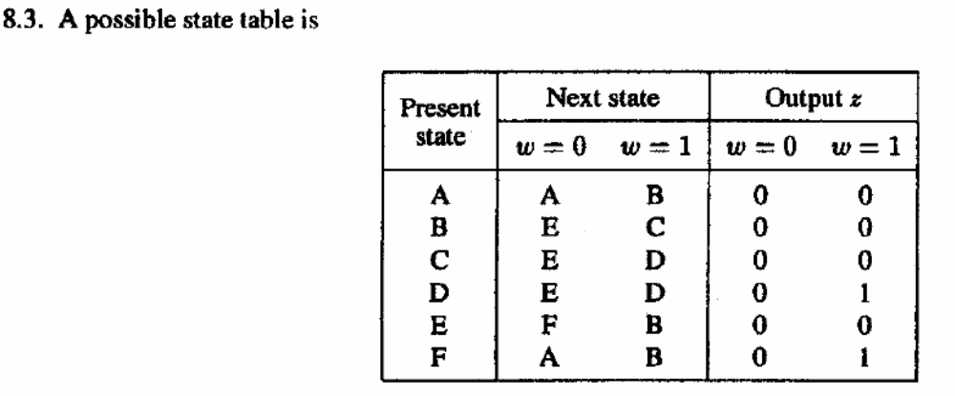

8.4

Question:

Solution:
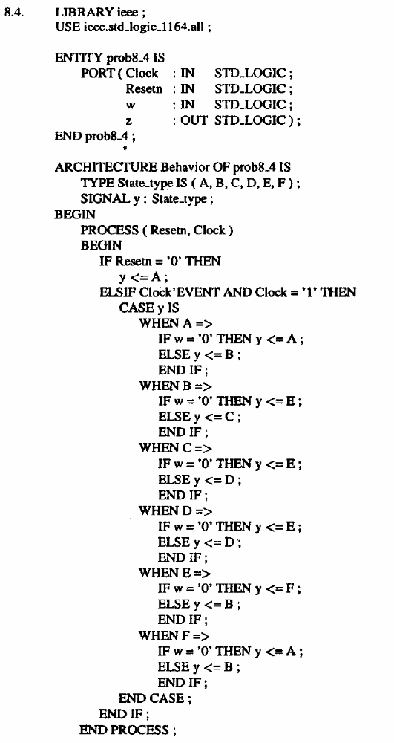

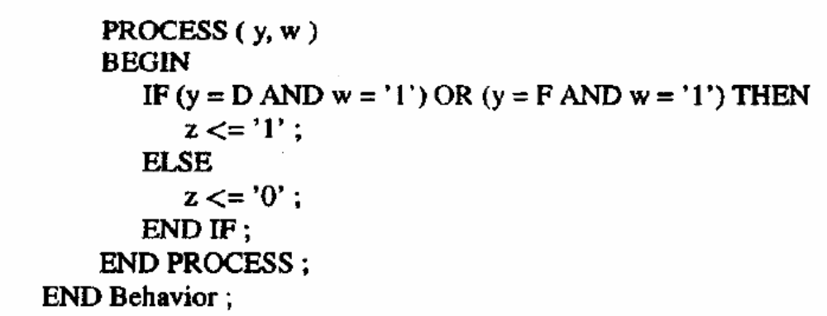

Question:
Repeat 3., 4. and 5. assuming you are designing a Moore machine

Solution:

8.9

Question:

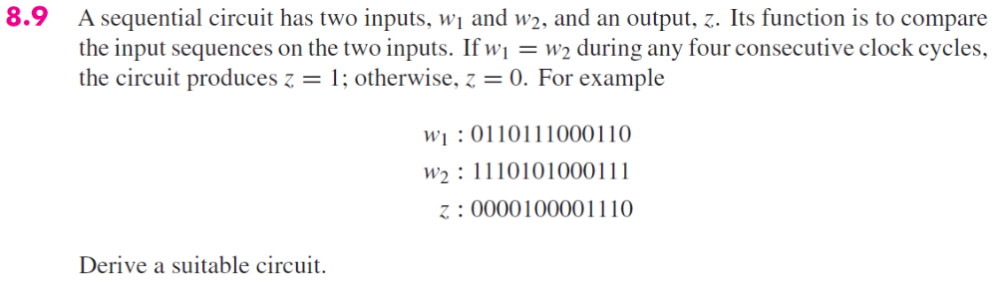

Solution:

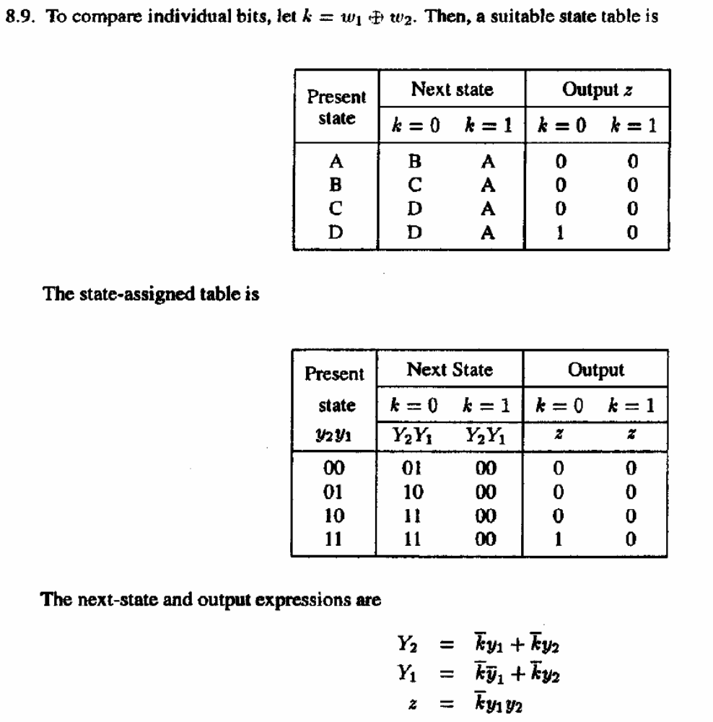

8.10

Question:

Solution:

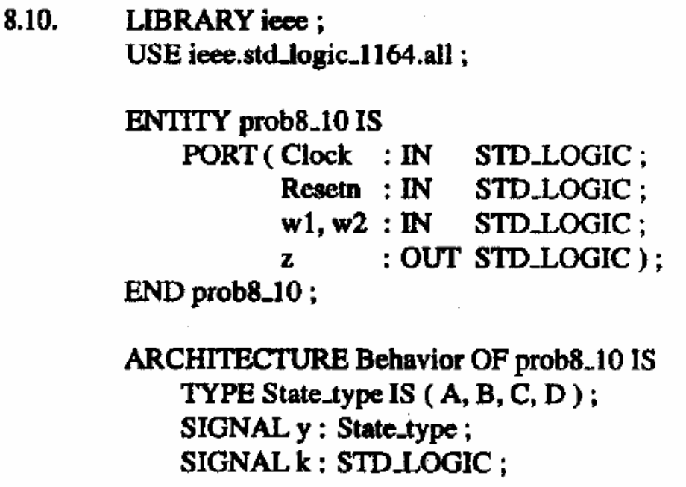
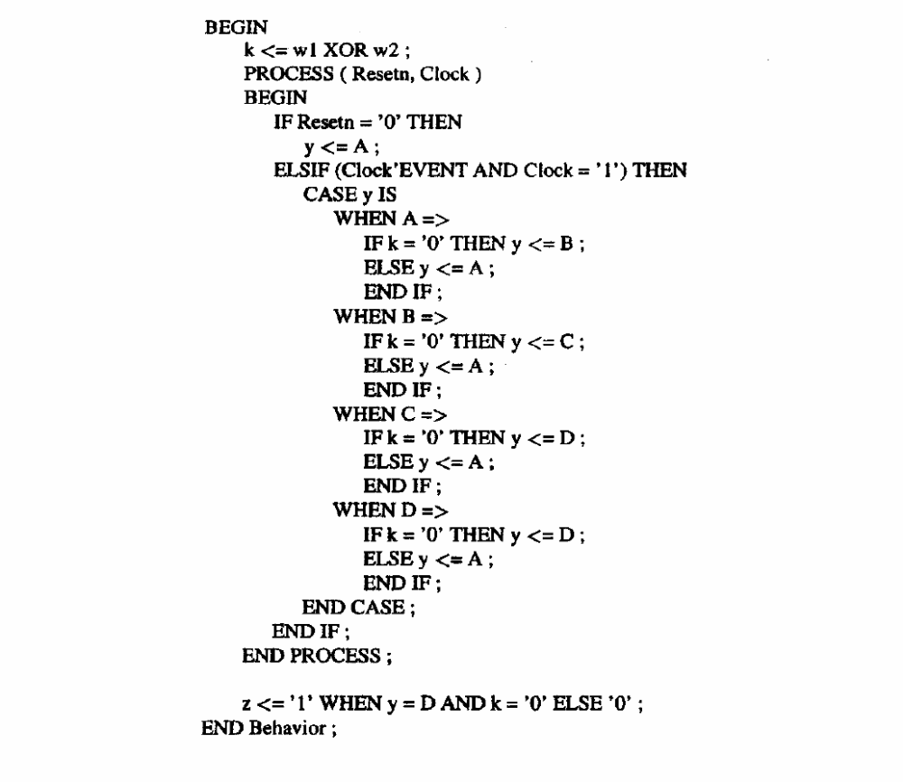

8.15

Question:

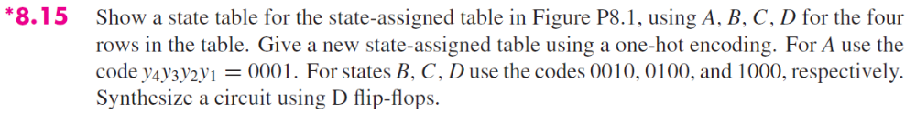

Solution:

